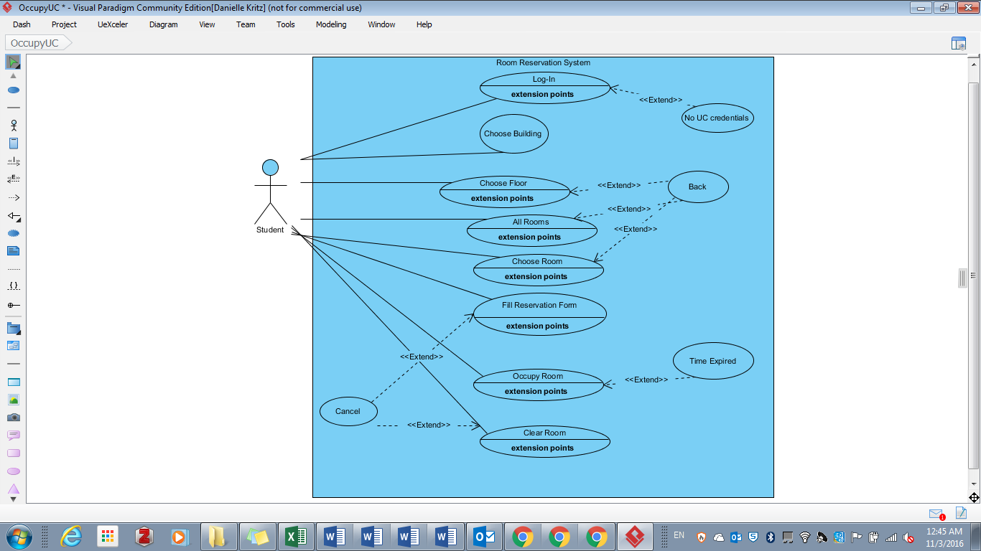

**Use case name:** Log-In/Enter Program

**Participating actors:** Initiated by Student

**Flow of events:**  1. Student enters username and password and presses log-in -OR- presses enter program button.

2. System presents main UI to Student (verifies student network credentials discreetly if no log-in panel)

**Entry Condition:**  1. Student must have UC credentials/be logged into the UC secure network

**Exit Condition:** 1. Credentials are confirmed.

**Use case name:** No UC Credentials

**Participating actors:** Communicates with Student

**Flow of events:**  …

**Entry Condition:**  This use case **extends** the Log-in/Enter Program use case. It is initiated by the System whenever the user trying to enter the program does not have valid UC network credentials

**Exit Condition:** …

**Use case name:** Choose Building

**Participating actors:** Initiated by Student

**Flow of events:** 1. Student selects desired academic building from map UI.

2. System displays drop-down for Student to then choose to view rooms by floor or all rooms.

**Entry Condition:**  1. Academic building must have rooms that are available to students.

**Exit Condition:** 1. A an academic building selection was made by Student.

**Use case name:** Choose Floor

**Participating actors:** Initiated by Student

**Flow of events:** 1. Student specifies floor where they would like to see room availability.

2. System displays available and unavailable rooms for floor chosen.

**Entry Condition:**  1. Academic building was chosen by Student.

**Exit Condition:** 1. Specific floor or Back is selected.

**Use case name:** All Rooms

**Participating actors:** Initiated by Student

**Flow of events:**  1. The Student selects the All Rooms option.

2. System displays available and unavailable rooms for all rooms.

**Entry Condition:**  1. Academic building was chosen by Student.

**Exit Condition:** 1. All Rooms option or Back is selected.

**Use case name:** Back

**Participating actors:** Initiated by Student

**Flow of events:**  1. Student presses the back button on the room viewing screen.

2. System displays the map UI.

**Entry Condition:**  This use case **extends** the Choose Floor/All Rooms/Choose Room use cases. It is initiated by the Student whenever the user wishes to return to the map UI or make another selection from the display of rooms.

**Exit Condition:** …

**Use case name:** Choose Room

**Participating actors:** Initiated by Student

**Flow of events:**  1. The Student selects the room of interest.

2. The System displays information for the room including available/unavailable status.

**Entry Condition:**  1. Student has selected floor or all rooms option.

2. Room is accessible to students.

**Exit Condition:** 1. Student selects the room, presses the back button, or selects Clear Room.

**Use case name:** Fill Reservation Form

**Participating actors:** Initiated by Student

**Flow of events:**  1. The Student fills in and submits information about their reservation of the room selected.

**Entry Condition:**  1. Student has selected an unoccupied room.

**Exit Condition:** 1. Student presses Cancel or Occupy Room.

**Use case name:** Occupy Room

**Participating actors:** Initiated by Student

**Flow of events:**  1. The Student presses the Occupy Room button after having filled in relevant information

2. System begins the reservation and changes room status.

**Entry Condition:**  1. Customer stands in front of the ordering kiosk.

2. Customer has pressed a sandwich category option.

**Exit Condition:** 1. Student selects Occupy Room.

**Use case name:** Time Expired

**Participating actors:** Communicates with Student

**Flow of events:**  …

**Entry Condition:**  This use case **extends** the Occupy Room use case. It is initiated by the System whenever the reservation time expires before the Student clears the room.

**Exit Condition:** …

**Use case name:** Clear Room

**Participating actors:** Initiated by Student

**Flow of events:**  1. The Student selects the room he/she occupies.

2. System displays room information and clear room option.

2. The Student selects Clear Room.

**Entry Condition:**  1. Student is currently occupying the room (aka reservation in the system).

**Exit Condition:** 1. Student presses the Cancel button or Clear Room button

**Use case name:** Cancel

**Participating actors:** Initiated by Student

**Flow of events:**  1. The Student presses the Cancel button.

2. System displays the previous screen.

**Entry Condition:**  This use case **extends** the Fill Reservation Form and Clear Room use cases. It is initiated by the Student whenever he/she wishes to return to the previous screen without making any changes.

**Exit Condition:** …